

**Automation Logic**

DevOps Assessment

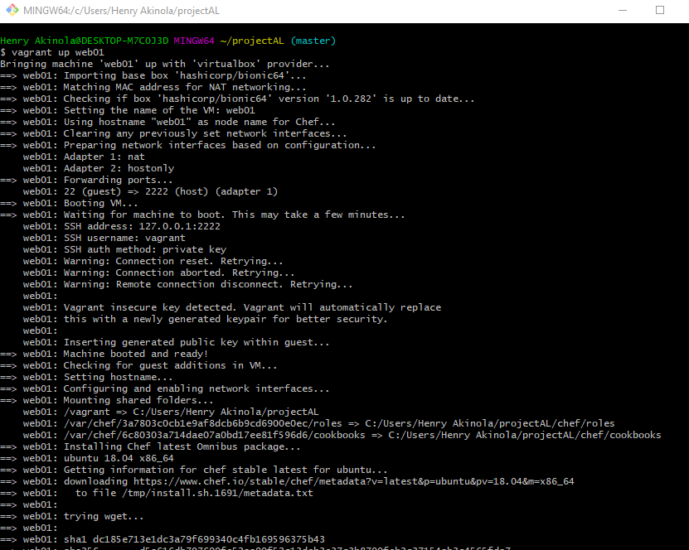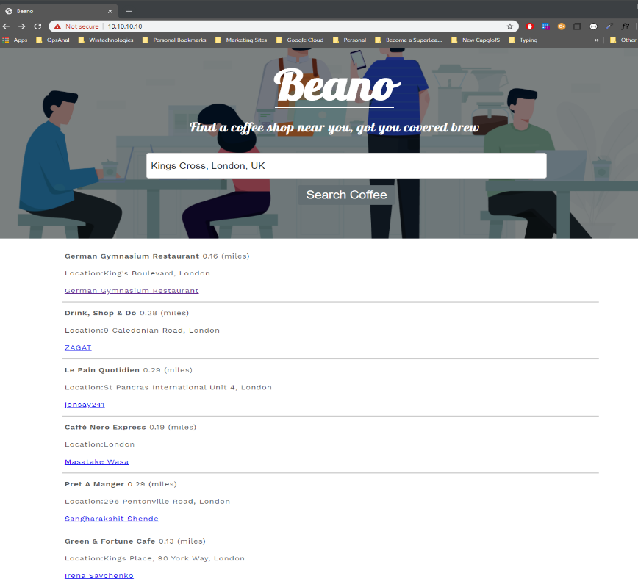

**Written By**

**Henry Akinola**

Summary 3

Project requirements: 3

Pre-requisites 4

Enable virtualisation on PC (Windows Only) 4

VirtualBox – Installation steps 4

Vagrant – Installation steps 5

Git - Installation steps (Command line Tool) 5

Chef-solo and not Chef Server? 6

Git Repository – Clone Project 6

Testing the web App (Web browser) 9

Testing the Web App (Shell Script) 10

Configurations – Technical Overview 11

Directory list & Server Inventory (Tree) 11

Vagrant setup 12

Chef Provisioning and cookbooks 13

Nginx configuration 17

Improvements 18

Test Script 18

Troubleshooting steps 19

First attempt 19

Second attempt 19

Resolution 19

Google API set up for places information 20

API key generation 22

Steps to apply JavaScript 23

Vagrant commands 23

Time Taken 23

Resources/Learning 24

# Summary

This document contains the steps taken to complete this project. It will walk you through the pre-requisite installation and setup, automated deployment process, infrastructure and descriptions of the tools used. I will not be going over to much regarding the web dev section of the project as it is not within scope of this project.

## Project requirements**:**

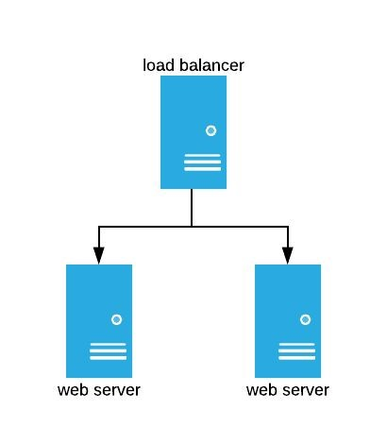

**2x Web servers** – Hosting a web app (**Beano – find a cafe near you using google places API**)

*The webservers will host an app that will dynamically retrieve cafés within a 500m radius of the location entered in the search input (****Google Places API****).*

**1x Load Balancer** – Will act as proxy to evenly distribute traffic to the webservers

**Vagrant** – Will provide the ability to build and provision the servers with associated files using a simple ***vagrant up*** command (More information to follow)

**Chef** – Will be used as the infrastructure configuration manager (cookbooks *no pun*, will be distributed to the servers based on roles applied to the servers)

**Test Script –** shell script to test the deployed web apps

# Pre-requisites

**PLEASE NOTE: In order to achieve a consistent outcome, it is advised to use the same version stated in this document. The steps shown is on a windows device, however providing the same tools and versions installed, should produce the same result.**

## Enable virtualisation on PC (Windows Only)

This is required to allow the ability of being able to run virtual machines on your machine. The guide below provides good clear instructions on how to enable this feature

<https://mashtips.com/enable-virtualization-windows-10/>

## VirtualBox – Installation steps

**In use version 6.1**

1. Select > <https://www.virtualbox.org/wiki/Downloads>

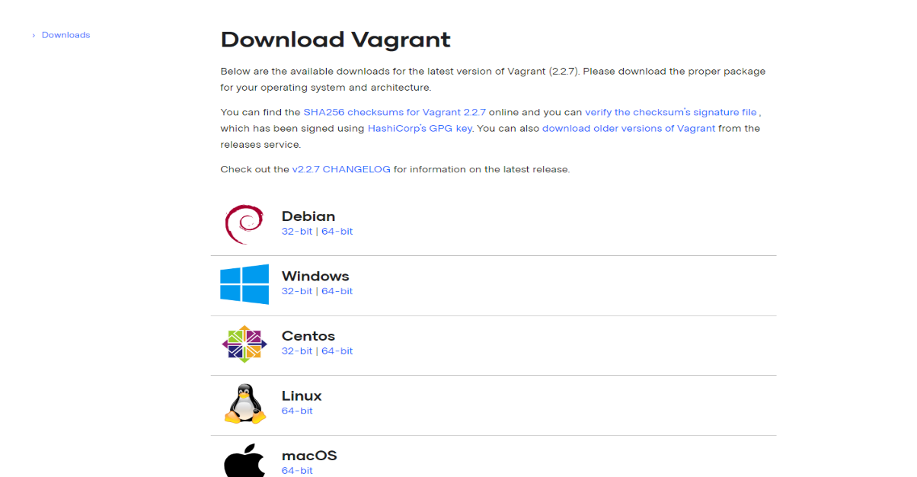

**Select the download that is compatible with your operating system**

1. Once downloaded navigate to your downloads folder and run the installation
2. Select **Next** all the way through, if prompted to install network interfaces select **Yes**
3. On The last screen select **Finish** to complete

## Vagrant – Installation steps

*Vagrant is a tool for building and managing virtual machine environments in a single workflow. With an easy-to-use workflow and focus on automation, Vagrant lowers development environment setup time, increases production parity, and makes the "works on my machine" excuse a relic of the past.*

To summarise why will be using vagrant for this project, is to mainly speedup the deployment of the virtual machines not having to manually download an iso mount the drive and repeat this for each server.

With the use of vagrant, you can simply point your Vagrantfile to a hosted iso in vagrants repo and easily spin up a VM with a single command **vagrant up** <optional machine name>. More details to come as we continue to build this project.

Manages Virtual machines,

* Easily create/destroy VMs
* Start/Stop and restart VMs
* Access to VMs
* Networking VM settings

**In use version 2.2.7**



1. Download Vagrant installer from <https://www.vagrantup.com/downloads.html> selecting your operating system.
2. Run Vagrant installer, Select **Next** all the way through accepting licensing agreements
3. Once installed if prompted to restart select **Yes**

Vagrant plugins – ominubus, berkshelf (optional no community cookbooks used)

## Git - Installation steps (Command line Tool)

Git is an opens source version control system used by developers. Version control systems keep these revisions straight, storing the modifications in a central repository. This allows developers to easily collaborate, as they can download a new version of the software, make changes, and upload the newest revision. Every developer can see these new changes, download them, and contribute.

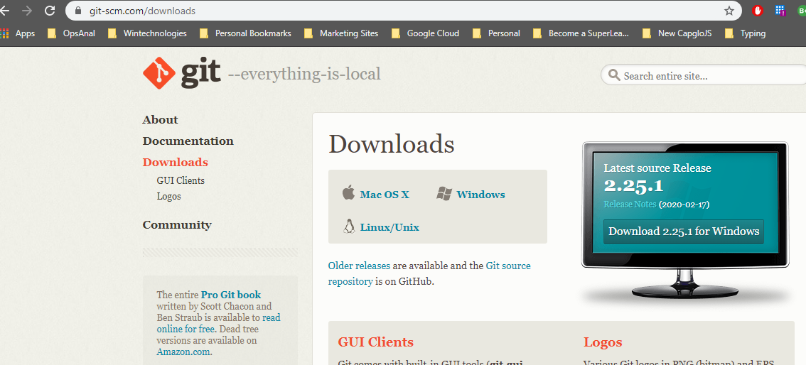

Download Git installed from <https://git-scm.com/downloads>

1. Once downloaded, the install should be found in your downloads folder *c:/users/<yourusername>/Downloads*
2. **Run** The download by double clicking
3. Select **Next** all the way through (**I Suggest to keep all the shortcut options checked**)

# Chef-solo and not Chef Server?

<https://blog.differentpla.net/blog/2014/11/13/which-chef/>

Being that the scope of the project is to build a small infrastructure consisting of 3 servers, I thought it would be best to use chef solo instead of creating a chef server as it will require a lot more configuration.

Chef-solo is a much lighter version of chef, If I were to use Chef-server, this will require a workstation that has chef-development kit installed on it. Chef clients deployed to each server along with validator certs. Using Chef-solo chef and its required config is installed independently on the machine to run locally. With the use of vagrant, I am able to specify the location of the cookbooks and assign each server chef roles that will be used to deploy the correct configurations on the servers.

**Manual Install is not required as this will be done at deployment phase.**

# Git Repository – Clone Project

Now that we have the tools that will be used out of the way. Next up is to clone the repository that contains all the vagrant file and associated project files.

You can either use your command prompt or simply use the terminal installed with the previous Git Bash install. **Git Bash** **Terminal used in steps shown**

**To confirm the pre-reqs has been installed**

command: **vagrant --version**

Check vagrant is installed and version

command: **vboxmanage --version**

Check Virtualbox version

command (if not using git bash): **git --version**

Confirms git is installed

**Providing no error found running the above commands, install the required plugins for our vagrant build:**  
command: **vagrant plugin install vagrant-omnibus**command: **vagrant plugin install vagrant-vbguest**

1. Select **Start button** > type (**Git bash**)

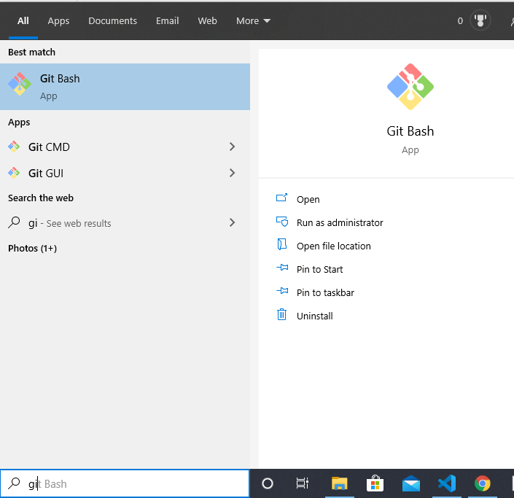

1. 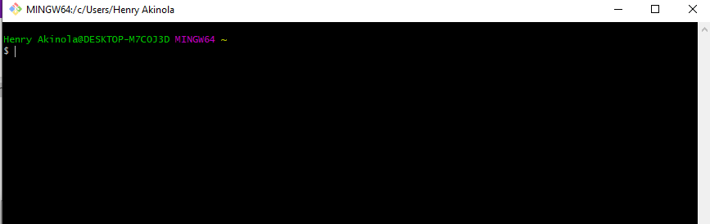Select **Git** **bash** you should be presented with a terminal screen
2. Make sure you are in a directory you wish to store the project files in. type **pwd** and press enter. This will show you the current directory you are in (Git bash usually opens in youre the root of your home directory)

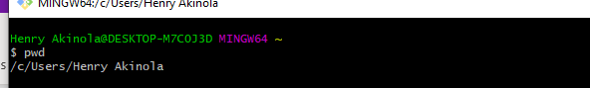

1. ***Optional step: if you prefer to load files in your Documents folder simply type cd ~/Documents***
2. Type: **git clone** [**https://github.com/henry89/projectAL.git**](https://github.com/henry89/projectAL.git) **and press enter. Desired outcome below**

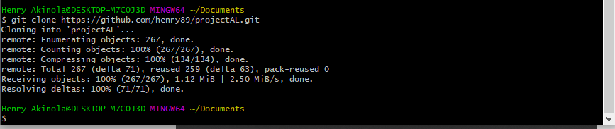

1. Navigate to the cloned folder.Type: **cd projectAL**

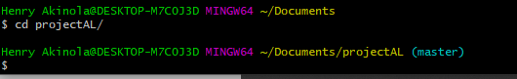

1. Providing that the pre-requisites install and setup has been completed, you should now be able to simply type: **vagrant up** in the terminal window

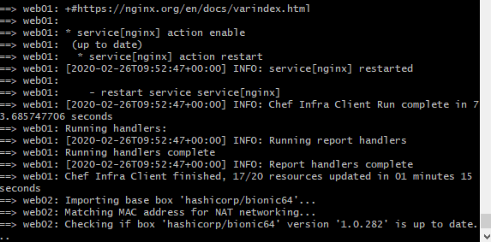

**The install should take around 10 minutes to deploy. Once completed you should be met with the following screen**

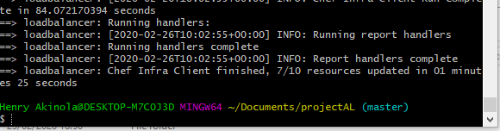

## Testing the web App (Web browser)

* In your web browser navigate to <https://10.10.10.10>

You should be presented with the following webpage

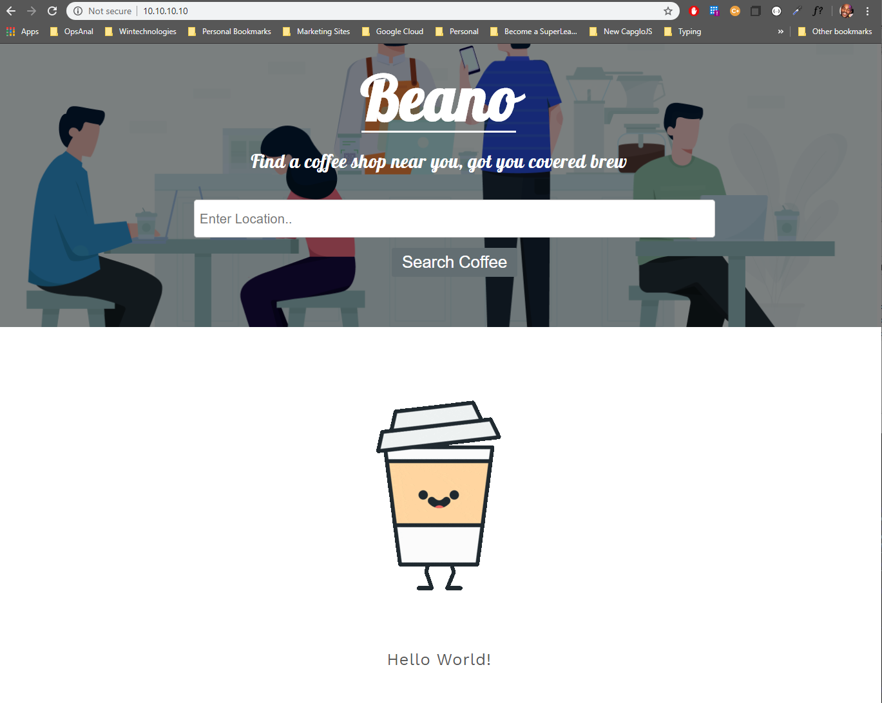

* You can now type in and search a location within the input

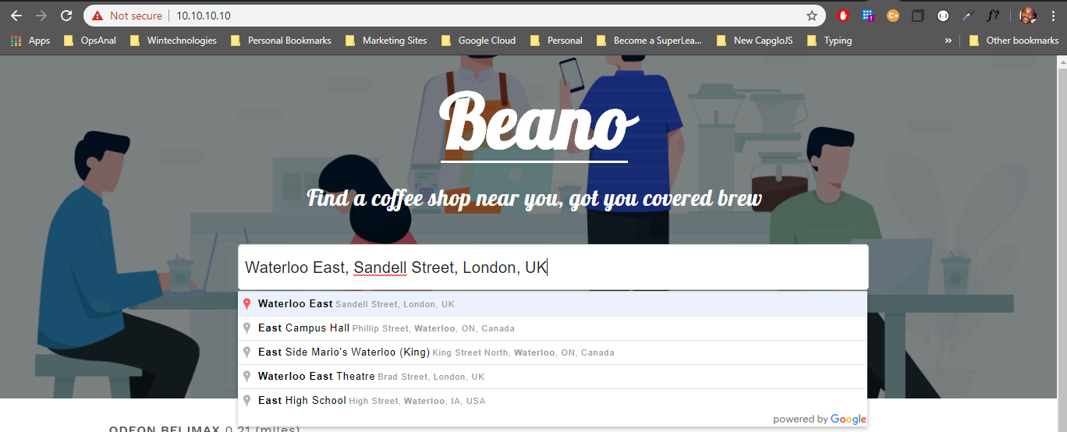

* Upon selecting your location, you will be able to see a list off cafes with in a 500m radius of the specified address. (Asynchronous request – no page refresh)

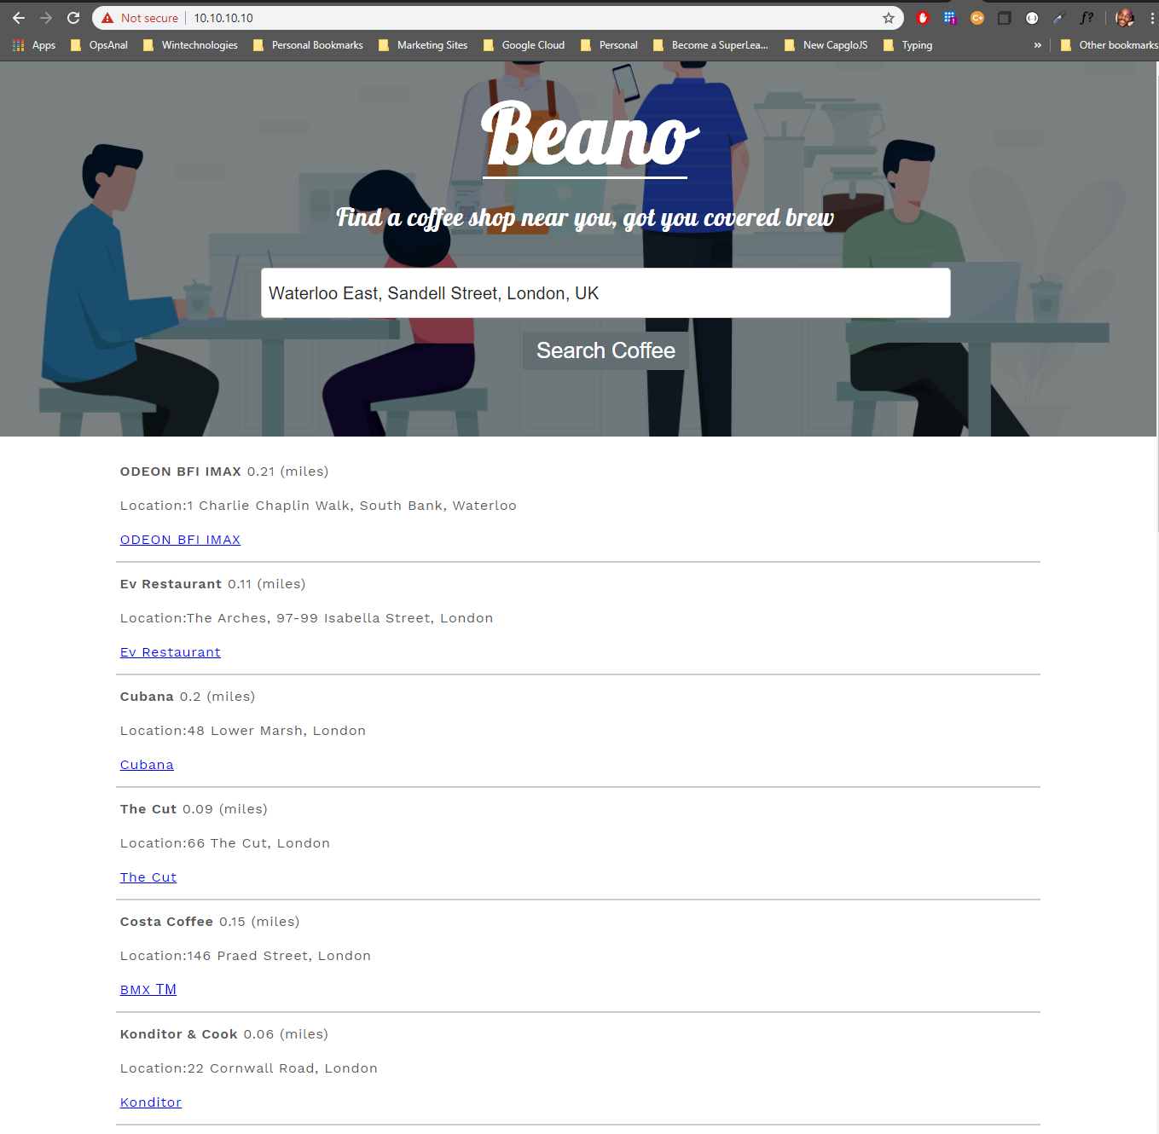

## Testing the Web App (Shell Script)

Within the files/folders cloned from the git repository, there is a directory called scripts in the root folder

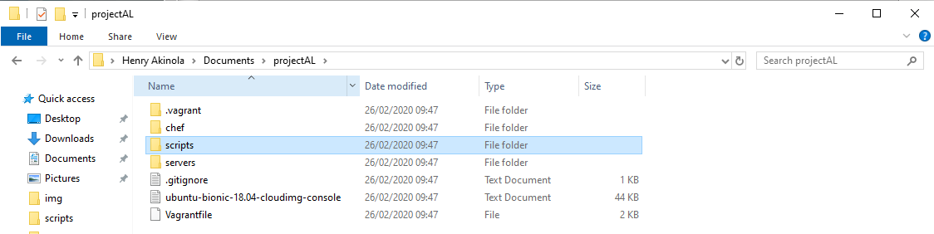

1. **Open** the scripts directory
2. **Double click** on the **web-health** shell script

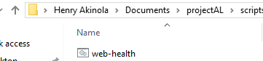

The following screen should show with the output results of the test

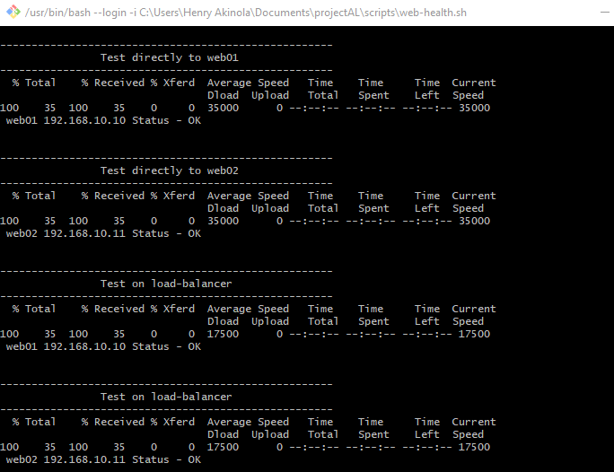

Providing that requests where successful you should see a success message of status ok on all checks

*web02/01 192.168.10.11 Status - OK*

# Configurations – Technical Overview

## Directory list & Server Inventory (Tree)

Below is the server list configuration and the directory listings. I decided to go with putting the basic server configs into a yaml file instead of hardcoding it in the vagrant file, this will make it easier to make adjustments to the server set ups if/when required. I limited it to just sever names and IPs. this can be broken out even further supplying information such as the CPU, memory, OS and much more.

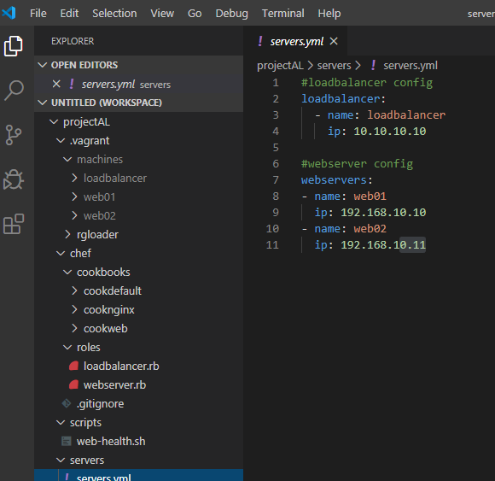

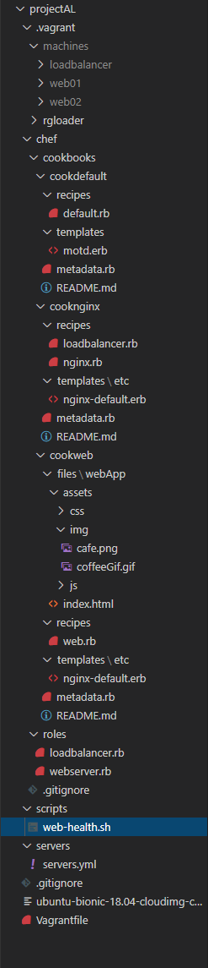

## Vagrant setup

The following script executes the following:

* Includes the **YAML** module to allow for the import of the **server.yaml** file that will be used later on in the script.
* Vbguest has been set to auto update

*Experienced issues when attempting to install packages, installing the updated resolved the issue.*

* The script first loops through the webservers listed in the **servers.yml**  and begins to set up
  + The box **hashicorps/ubutu64** box is then pulled from vagrant cloud
  + Hostname of the server is set using the name entry found in the **servers.yml**
  + The hypervisor is the triggered to start creating the virtual machine with the specified name.

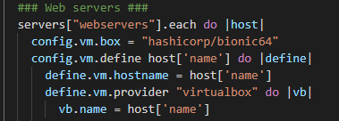

* + SSH is enabled and the private IP address is using the IPs specified in **servers.yml**

The chef provisioning block will take affect:

* + Taking care of licence agreement prompt (No user interaction required)
  + Assigning the provisioning path this is automatically set (Optional - details on why it has been set in Troubleshooting chapter)
  + Chef cookbooks path set (root of all cookbook directories) this will be assigned to a path within the virtual machine at build along with the roles

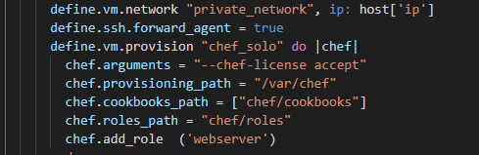

## Chef Provisioning and cookbooks

**Roles**

Roles where used to avoid the need to have to specify the run list within the vagrant file for each server, run list meaning what recipes/configurations that should run against the server. Chef will automatically look in the roles directory to find the roles and run the recipes defined within its role file on servers tagged with that particular role.

**Roles Directory**

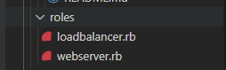

**Vagrant file – applying roles**



**Load balancer role – displays run list**

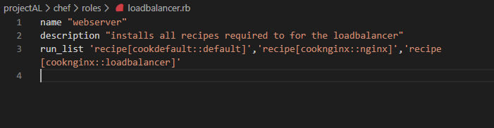

**Webserver role – displays run list**



**Default recipe**

This was set up initially to test cookbook settings

* Installs emacs and tree

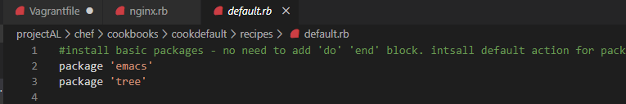

**Nginx recipe**

* Install Nginx
* Comment out **octect stream** line – when navigating on the website, it causes the web page response to be returned as binary data ultimately leading to the browser downloading it as it does not know how to interpret it
* Updated the **/etc/nginx/sites-enabled** default file with a commented out line.

This file is included in the main nginx config **/etc/nginx/nginx.conf.**

I could have simply used the same function to replace the included sites default line in the nginx config, however I wanted to utilise the chef **file resource** functionality to show some of the other options available within **Chef**.

* The Last config is to enable and start **Nginx**

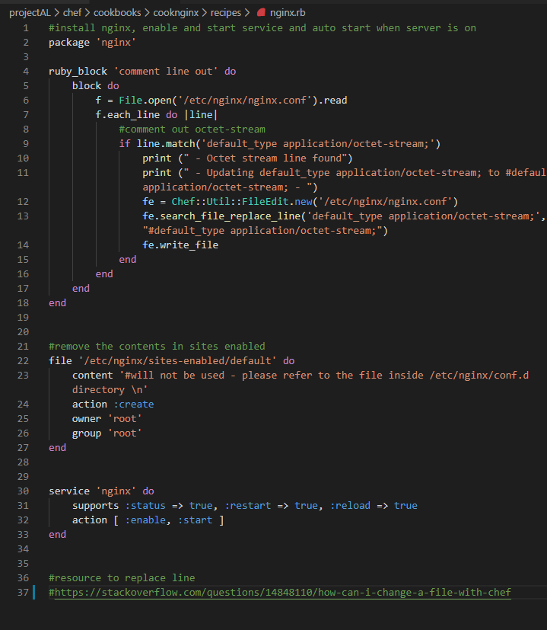

**Loadbalancer recipe**

* Creates a file in **etc/nginx/conf.d** directory using the template file provided in the templates directory
* Restarting the Nginx service to make sure changes take affect

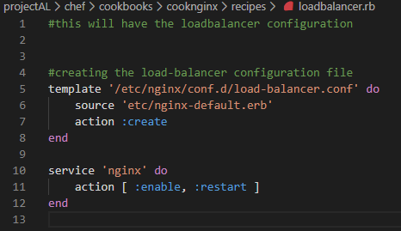

**Template file – nginx-default.erb**

* Listening on port 80 distributing requests to the specified servers

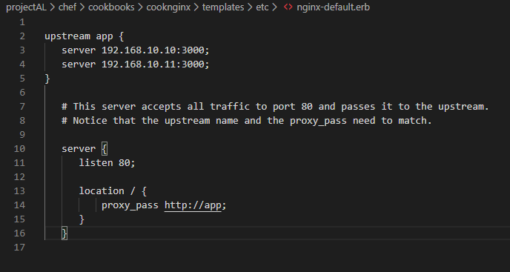

**Web recipe**

* Very similar to the load balancer recipe, it contains a chef remote_directory resource enabling the feature of copying directories to a specified folder. In this case I used it to copy the web app to the /var/www directory within the server.

Setting the permission on that folder to read/write/execute for root and only read for users.

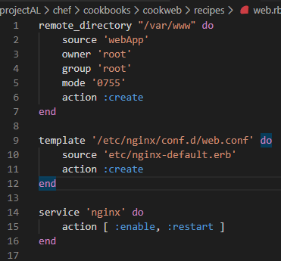

**Template used for the Nginx config**

* Listening on port 80

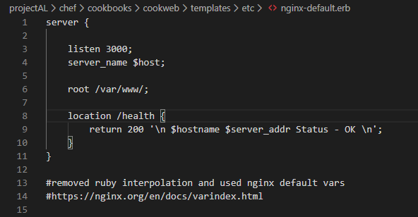

## Nginx configuration

**/etc/nginx/nginx.conf**

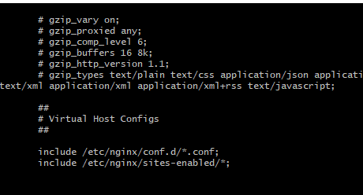

By default nginx will run both the configuration in **"/etc/nginx/sites-enabled/default"** and **“/etc/nginx/conf.d/”.**

As mentioned in the cookbooks chapter of this document, the nginx config files is created and pushed to the **“/etc/nginx/conf.d/”** directory.

The load balancer is listening on port 80 and distributing the traffic to the two web servers on port

3000.

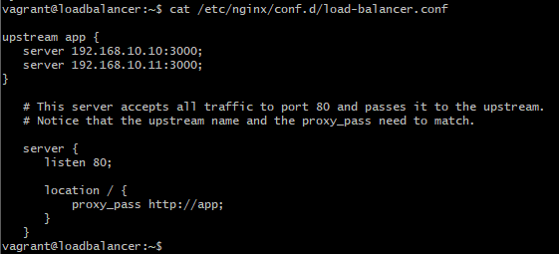

The webservers are set to only accept web traffic on port 3000

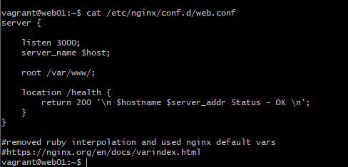

#### Improvements

Currently there is no way of blocking users attempting to directly access the webserver providing they know the IP address on port 3000.

If I was to improve this setting, I will update the firewall settings to only accept request from the load balancer on that port.

#### Test Script

**There is a shell script in scripts/web-health.sh**

The script is fairly straightforward, it simply sends a curl request multiple times to both web servers and to the load balancer to **/health** route. Returning the status.

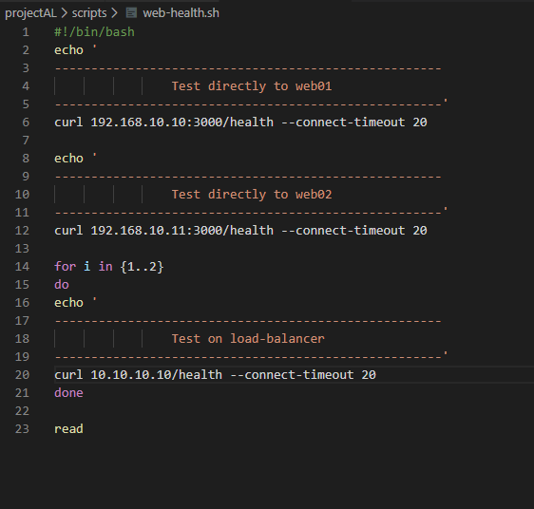

### Troubleshooting steps

* Cookbooks not being found

When initially deploying the cookbooks, I was specifying the full path of each cookbooks in the vagrant file which when loaded caused the virtual machine to mount them into their own individual directory.

When attempting to run the cookbooks, I kept getting met with the cookbook not found.

#### First attempt

Was to explicitly set the chef provisioning directory.

Doing this did not fix it, as it was doing the same thing within the newly set provisioning directory – ***Daft move***

#### Second attempt

As the box was already built but not properly configured, I was still able to SSH on to it. I then attempted to run the chef cookbook manually.

I navigated to the chef cookbooks directory as seen in the image and executed the following command to run the cookbook recipe locally**- chef-client –z cooknginx/nginx.erb**



***That worked!***

***However, the main purposes of the project is to keep the user interaction at build and configuration to a minimum.***

#### Resolution

*Simple fix in the end was to not put the full path of the cookbooks and filename but to just provide the path of where all the cookbooks reside.*

***Correct***

"chef/cookbooks"



***Incorrect – cookbook name not required***

"chef/cookbooks/cookweb"



*This will then mount all the cookbooks in that directory into one directory on the server*

## Google API set up for places information

1. Sign up to google cloud - <https://cloud.google.com/>

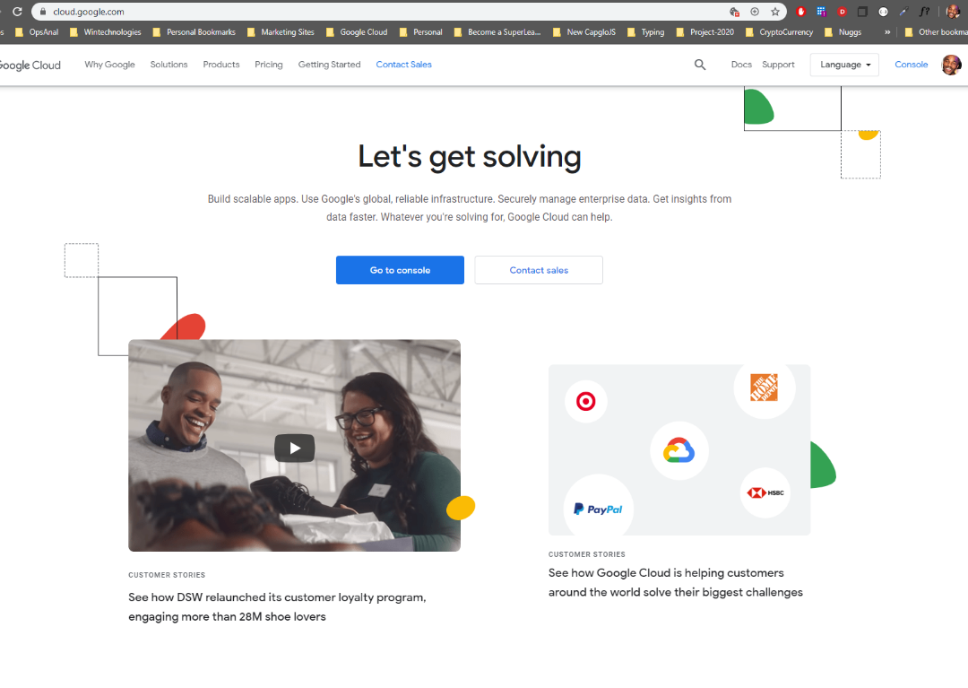

1. Create a project

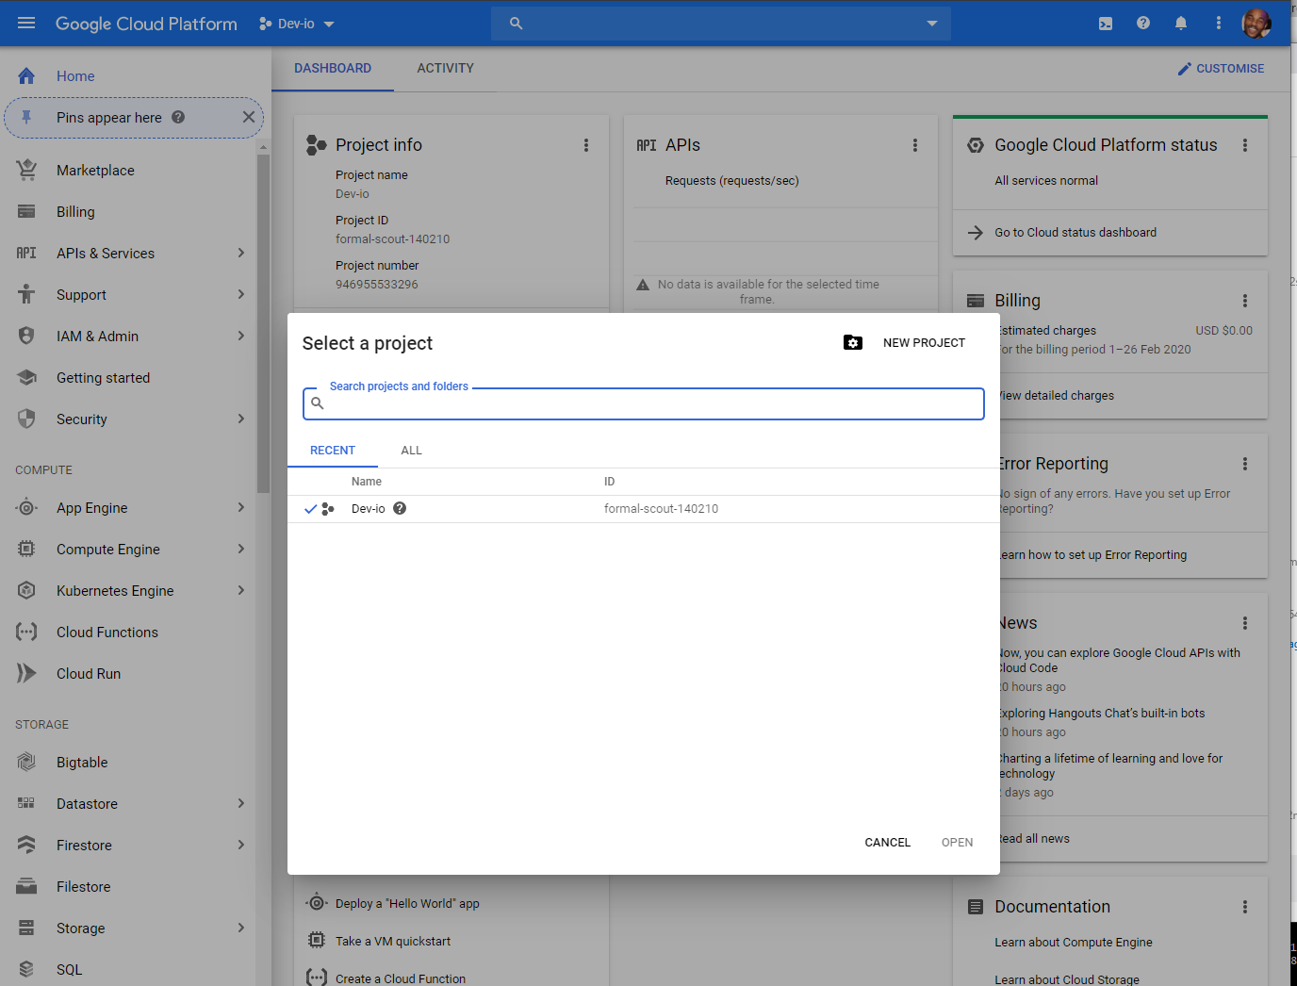

1. Select API libraries

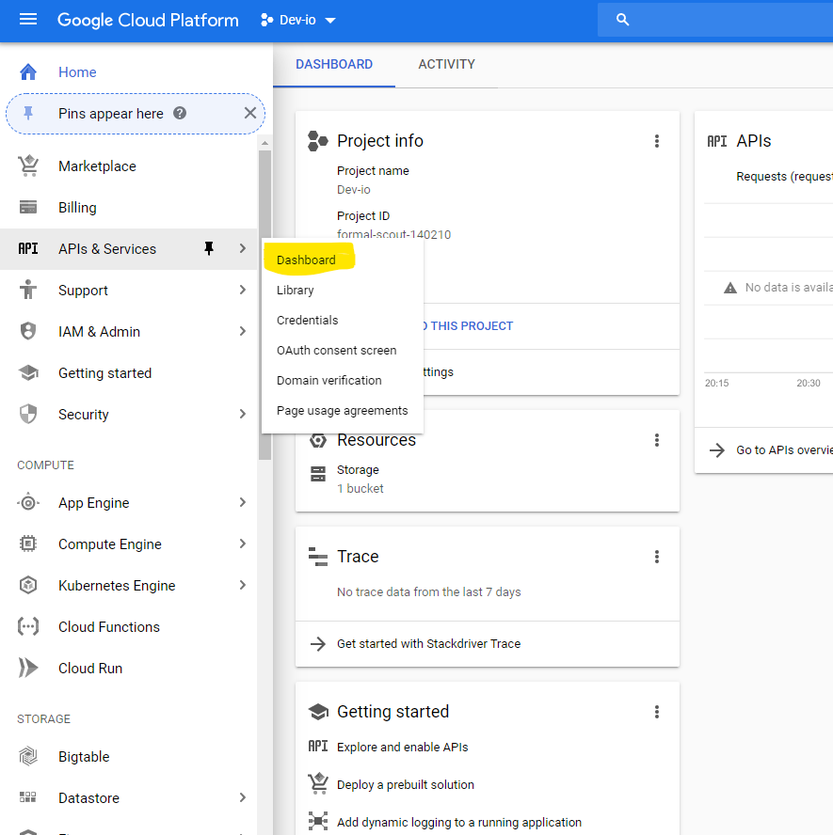

1. **Select** ENABLE APIS AND SERVICES

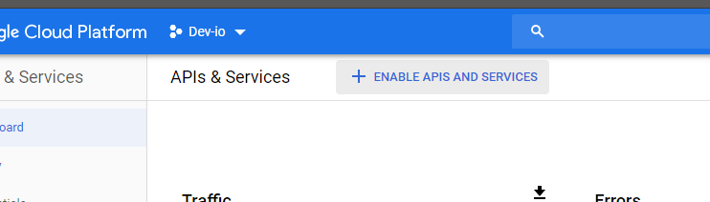

1. **Search** Places (you will be prompted to add authentication mechanisms – required for you to make requests to Google API)

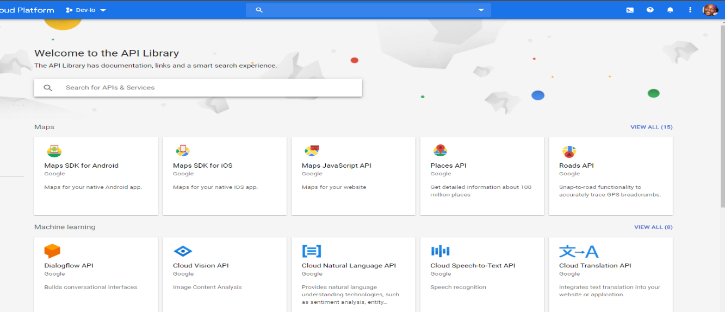

1. Billing will need to be enabled to use the place API

<https://developers.google.com/places/web-service/usage-and-billing>

#### API key generation

**PLEASE NOTE: I have currently created a API Key for the purpose of this project once used I will be removing the key.**

1. Navigate back to the Dashboard settings **(Step 3)**
2. **Select** Credentials (Left pane)
3. On the credentials screen select +CREATE CREDENTAILS (Top of screen)

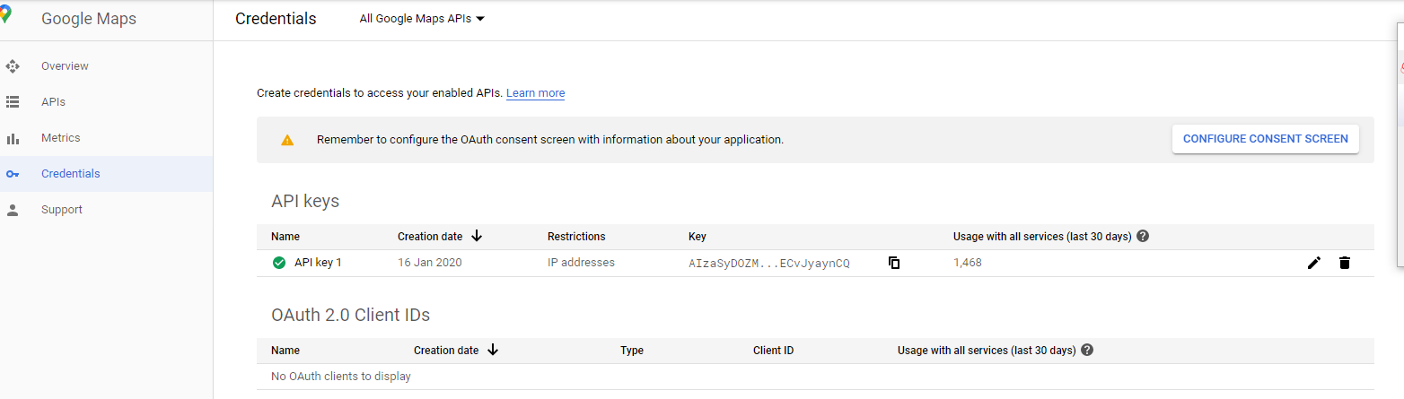

1. You will be presented with a popup with options to copy and restrict key

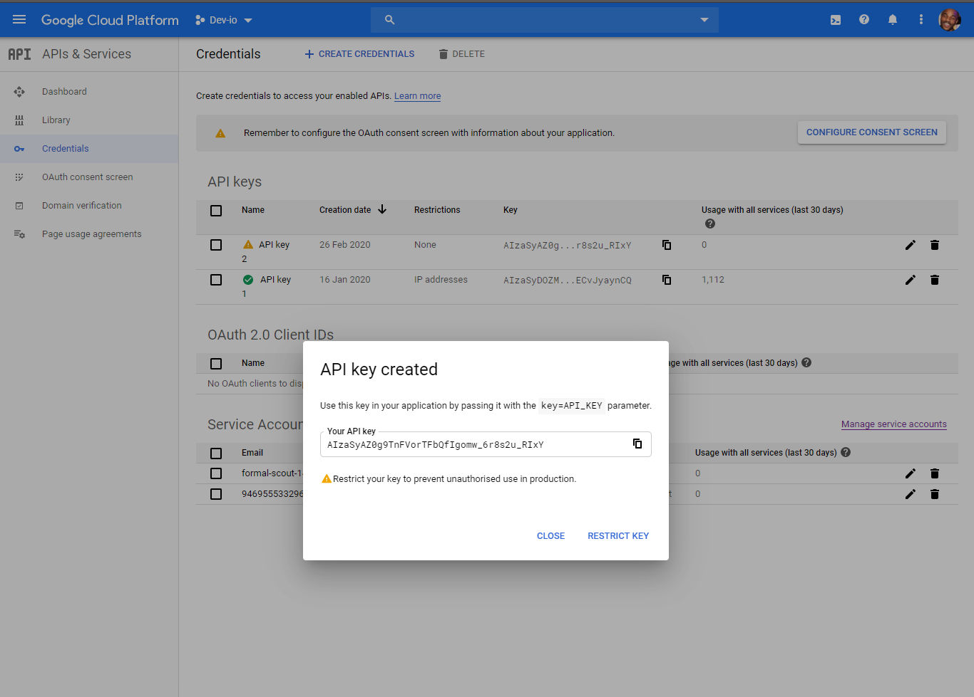

#### Steps to apply JavaScript

<https://developers.google.com/maps/documentation/javascript/places#place_search_requests>

**At the bottom of the index.html file I added the places api link below above the custom script that will be handling the search form on the page.**

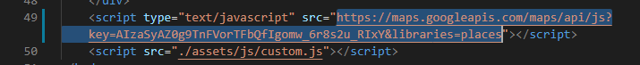

**Order of operation this will ensure the google components is available within the custom script.**

Without boring you with the details of the custom script as it is out of the scope of the project. Upon entering a location in the search field using the longitude and latitude data to retrieve cafés within a 500m radius from Google Places API. Then transformed to output the results in a list format on to the page.

**Please see Testing chapter for app demonstration**

# Vagrant commands

**Vagrant init** - will create a vagrant file

**Vagrant up *<optional machine name>*** - will spin up specified machine or any configured machine specified in the vagrant file

**Vagrant halt *<optional machine name>*** - will shut down all or specified machine

**Vagrant destroy *<optional machine name>*** - Will shut down and delete any specified virtual machines

**More on:** <https://www.vagrantup.com/docs/cli/>

Time Taken

**Research/Study - 5/6 hrs**

**Vagrant setup – 1 hrs**

**Chef Configurations/cookbook creation – 3 hrs**

**Documentation – 3/4 hrs**

**Testing/Troubleshooting – 2/3 hrs**

**Creating the web app – 2 hrs**

**Creating shell test script - .5 hrs**

**Estimated Completion time 20 Hours**

# Resources/Learning

**Vagrant Docs**

<https://www.vagrantup.com/docs/index.html>

<https://www.vagrantup.com/docs/provisioning/chef_solo.html>

**Vagrant/Chef Video Tutorials**

<https://www.udemy.com/course/vagrant-up/>

<https://www.udemy.com/course/chef-fundamentals-a-recipe-for-automating-infrastructure/>

**Chef-Solo**

<https://docs.chef.io/chef_solo.html>

**Nginx load balancing**

<https://www.digitalocean.com/community/tutorials/how-to-set-up-nginx-load-balancing>

**Google docs**

<https://developers.google.com/maps/documentation/javascript/places-autocomplete>

<https://developers.google.com/places/web-service/web-services-best-practices>

**Haversine Algorithm**

<https://cloud.google.com/blog/products/maps-platform/how-calculate-distances-map-maps-javascript-api>